Scanning Activities :

Our objective for this activity is to conduct a scan. To that end, I selected the Pingplotter application, which is available on all computer platforms and will provide us with a more thorough view of the information we seek. This includes information such as hops, the time it takes to get there, the health of our network, packet tracking, and more.

This is a screenshot of the application when it is initially launched:

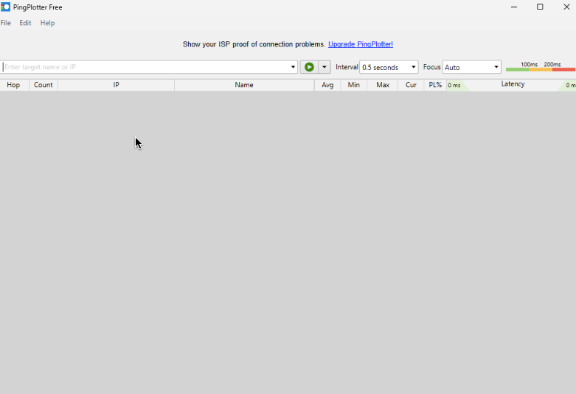

The top left corner of the screen allows us to trace our route to a website or an IP address. Generally, when diagnosing network problems, you want to trace to a stable server that has an expected outcome, so you have a baseline to compare against. Google's 8.8.8.8 server is one of the more well-known DNS servers that is frequently used due to its low latency; here, we will enter the IP of that DNS server and click start:

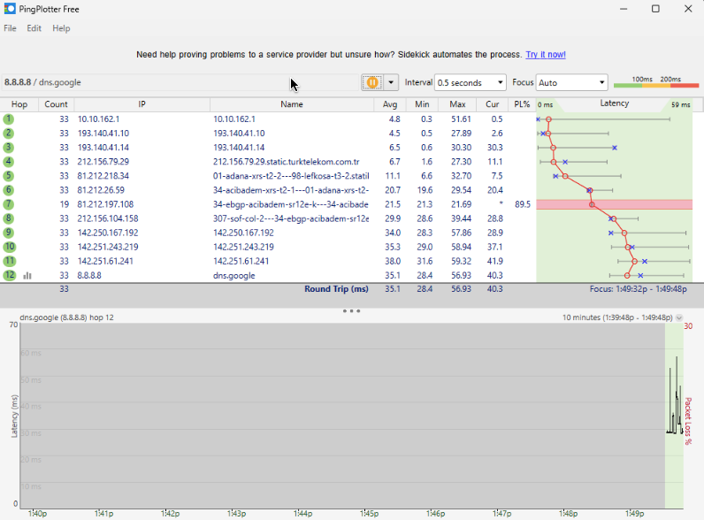

Our LAN IP is 10.10.162.1, and we can use this information to determine that it is our local IP for the main hub/router. Additionally, we can see a graph at the bottom of the app that shows the roundtrip time in MS, which allows us to conclude that the internet is local up until the second hop because we observe an increase in latency after hop. After entering our desired IP (in this case, 8.8.8.8), the programme will begin to trace the packet all the way from your LAN to the target. Since we are using this app, it also provides us with the IP address of each server our packet travels through

2. If we examine hop 5, we can see that it travels from Famaggusta, our home city, to Lefkosa, another nearby city. This suggests that the primary link for Cyprus is at Lefkosha. Next, we observe a significant increase in latency in hop 6, which, as the server's name implies, is where internet from Lefkosa travels to Turkey—more specifically, to Adana. With this information, we now know the source of Cyprus' internet!

We observe a significant packet loss in hop 7, and while the earthquakes may have disrupted the main lines, we now know who is to blame for the poor internet speeds in Cyprus. Move on, Broadmax!

Hops 9 through 11 show us that Since the IP address doesn't fluctuate much, we have reached an internal server. If we investigate that IP, we will find:

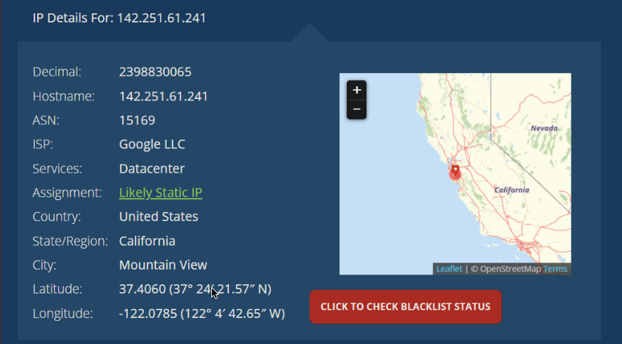

We can see from the IP lookup that we have arrived in California and that the IP is registered under Google's name, which indicates that we have successfully reached the intended DNS server.

Using this application (ping plotter), we can have some proof or evidence if the issue is from our ISP or not, if there was ever an issue! Overall, this was a very fun experiment to try and figure out what route your packet takes to arrive at the server you're requesting data from. We can see how easy it is to determine the causes of internet issues!

It's also crucial to remember that our programme will generate more accurate findings the longer it runs; after ten minutes of running time:

